The ABCs of [insert novel title here]
The Task Overview: Now that you’ve finished your novel, you are going to use everything you’ve understood to create a Reader’s Guide to your novel: The ABCs of [insert novel title here].
Steps:

- For each letter of the alphabet, choose something from the book that starts with that letter. This can be a person, place, thing, concept, or idea. EXAMPLE:
C is for Mr. Coombes
Writing Process Tip: Brainstorm many different possibilities for each letter!
Writing Process Tip: PLAN your letters / words carefully! Keep a working OUTLINE!

- For each item, write a brief paragraph to explain / define the significance of this person, place, thing, concept or idea to the novel. Use brief quotes from the text to demonstrate its importance. EXAMPLE:
C is for Mr. Coombes
In Boy, Roald Dahl’s Headmaster at Llandaff Cathedral School is named Mr. Coombes. He is an angry man with “a face like a ham” and he always wears “a dangerous scowl” (Dahl 41). Mr. Coombes is the headmaster who punished Roald Dahl and his friends because of The Great Mouse Plot in Mrs. Pratchett’s shop. Roald Dahl’s mum was so upset by Mr. Coombes’s punishment that she removed her son from the school. Mr. Coombes is a source of real external conflict in Boy.
Writing Process Tip: Draft, seek feedback, edit, re-draft, proofread, finalize!
- Add relevant and original images or artwork to each entry. EXAMPLE:

- Arrange your letters and entries so that there are NO MORE than two letters (with explanations) per page. EXAMPLE:
C is for Mr. Coombes  In Boy, Roald Dahl’s Headmaster at Llandaff Cathedral School is named Mr. Coombes. He is an angry man with “a face like a ham” and he always wears “a dangerous scowl” (Dahl 41). Mr. Coombes is the headmaster who punished Roald Dahl and his friends because of The Great Mouse Plot in Mrs. Pratchett’s shop. Roald Dahl’s mum was so upset by Mr. Coombes’s punishment that she removed her son from the school. Mr. Coombes is a source of real conflict in Boy.  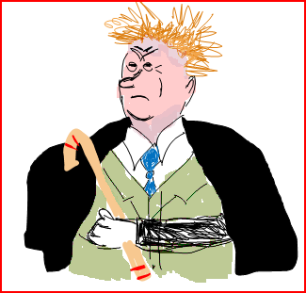 | D is for Didgeridoo  Blah blah blah blah blah blah blah blah blah blah blah blah blah blah blah blah blah blah blah blah blah blah blah blah blah blah blah blah blah blah blah blah blah blah blah blah blah blah blah blah blah blah blah blah blah blah blah blah blah blah blah blah blah your writing will be much more interesting than this because this is simply an example for you to look at in terms of layout.

- Arrange your pages in alphabetical order so that they read like a book, with pages BACK-TO-BACK.

- Design and create a cover for your book then bind the whole thing together!

