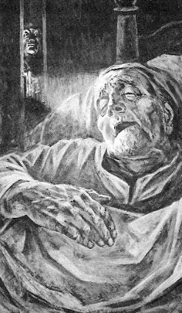
The Tell-Tale Heart

How far do you agree with each statement?

10 = completely agree 1 = totally disagree 7 = not allowed!

1. People who are insane know that they are insane. ________

2. Sane people sometimes imagine that they hear things. ________

3. If you commit a crime, the worst punishment is the guilt afterward. _______

4. Often it’s the small annoying things about people that can be the most irritating and infuriating._________

5. All people are basically afraid of the same things.________

6. When you’ve done something wrong, wondering if you’ll be caught can cause great stress and anxiety.____________

- Read the extract below along with me.

- Give three direct and specific examples from the story that the author uses to create an atmosphere of horror or suspense. These are sentences that set or enhance the MOOD of the story.

- Explain why underneath.

EXTRACT
No doubt I now grew very pale; --but I talked more fluently, and with a heightened voice. Yet the sound increased --and what could I do? It was a low, dull, quick sound --much such a sound as a watch makes when enveloped in cotton. I gasped for breath --and yet the officers heard it not. I talked more quickly --more vehemently; but the noise steadily increased. I arose and argued about trifles, in a high key and with violent gesticulations; but the noise steadily increased. Why would they not be gone? I paced the floor to and fro with heavy strides, as if excited to fury by the observations of the men --but the noise steadily increased. Oh God! what could I do? I foamed --I raved --I swore! I swung the chair upon which I had been sitting, and grated it upon the boards, but the noise arose over all and continually increased. It grew louder --louder --louder! And still the men chatted pleasantly, and smiled. Was it possible they heard not? Almighty God! --no, no! They heard! --they suspected! --they knew! --they were making a mockery of my horror!-this I thought, and this I think. But anything was better than this agony! Anything was more tolerable than this derision! I could bear those hypocritical smiles no longer! I felt that I must scream or die! and now --again! --hark! louder! louder! louder! louder!
"Villains!" I shrieked, "dissemble no more! I admit the deed! --tear up the planks! here, here! --It is the beating of his hideous heart!"

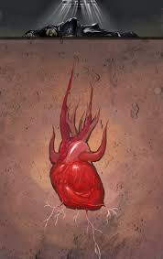
Now try to recreate your own murder using Poe’s style.
You might wish to include:
- A bleak setting and violence
- Lots of hyphens and exclamation marks
- Repetition
- A paranoid narrator
- Horrid sounds

