Paragraph Writing

Purpose of a paragraph:

- Separate different ideas
- Work together, cooperate with other paragraphs to unify the whole text's idea

Key features of a paragraph:
- Indentation
- One topic in the paragraph
- Topic Sentence which clearly states what the paragraph is about
- Supporting detail sentences (evidence) which add support to the main idea in the Topic Sentence.
- Closing / concluding sentence.

Criteria for a good paragraph: What makes a good paragraph? What makes it work?

The topic sentence is the first sentence in your paragraph.

It tells your reader exactly what the whole paragraph is going to be about. The topic sentence states the main idea of the paragraph.

It’s the topic sentence that tells us what details we can bring in. It is also the sentence that tells us what details we have to leave out. It sets the limits of all the details that go into the paragraph.

This diagram gives you an idea of how the topic sentence works.
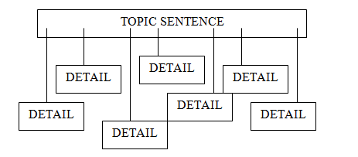

Look at the following diagram about Narrowing the Topic. What is the aim of doing this?
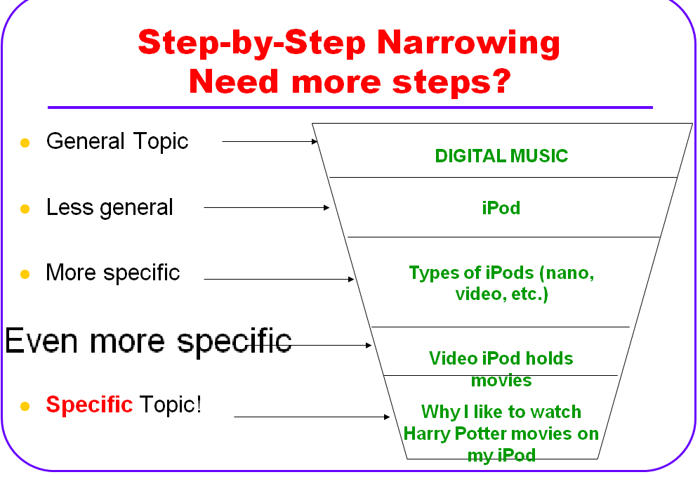

Now that you have managed to make it to Years 7 /8 you should be able to write more than just a single paragraph on the book you are reading. This means that you need to narrow down to several specific topics that make up one cohesive piece of writing. Can you predict what this might look like?

How Long should the paragraph be?
- 10-12 lines
- Approx. 140 - 160 words

