Eight ads that shatter tired gender stereotypes
As the Cannes Lions festival creates a new award to recognise advertising that challenges gender norms, we look at some of the best past examples

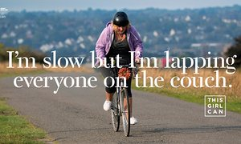
Sport England’s This Girl Can ad campaign breaks the rules of traditional sports advertising. Photograph: Sport England

Mel Exon and Melanie Arrow
Tuesday 26 May 201509.55 BST
Glass is a wonderful thing. Windows, vases, spectacles, marbles. Such a shame about that whole glass-ceiling thing, isn’t it? Really tarnishes the whole image of glass. At least the Cannes Lions festival has managed to turn it into something positive, in the form of their new Glass Lion award, created this year to recognise advertising that shatters gender stereotypes.
Advertising and the real world have diverged on gender. At its best, advertising contributes to culture, taps into the popular mindset and captures the moment. The modern mindset on gender, however, is moving much further and faster than how it is represented in advertising. In the real world, us women play sport, don’t always shave, burp, fart and are your boss. In the world of advertising, we are known to get all giddy over yoghurt and lose our cool at the sight of a chocolate bar. Then there’s the distinct absence of gay and transgender people to call out, which is exacerbated by the omnipresent (and frankly tired) portrayal of the shaving, beer drinking, have-it-all lad.
Of course, this is not true of all advertising, but the mere need for the Glass Lion award suggests that adverts which do shatter gender stereotypes are, frankly, not the norm. Below is our pick of eight ads that fall into the abnormal category, each of them questioning, challenging and playing with the idea of gender stereotypes.

1. Bodyform: The Truth (2012)
Bodyform’s campaign breaks the conventions of previous tampon adverts.
Even though Bodyform most definitely hit their advertising peak in the 80s (all together now; Woooooah Bodyform) this video response to a Facebook post on the Bodyform page is simply perfect – everything from the jug of blue liquid and clockwork orange-esque focus group footage to the fart. The fart makes it. This ad cuts through every nonsense mountain-climbing, horse-riding, “your period is as individual as you are” gender-stereotyped tampon advert that came before it. It is the final word.
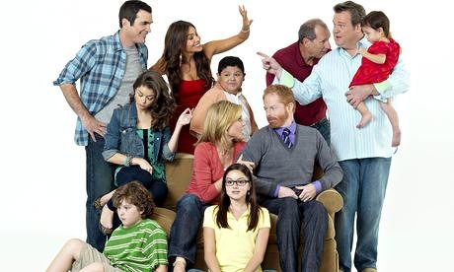

Modern family: can marketers catch up with culture?

Read more

2. Getup.org: It’s Time (2011)
Designed to promote marriage equality, this film portrays the progress of a relationship through the eyes of one member of a gay couple. It challenges any lingering preconceptions of what an authentic on-screen relationship looks like and in doing so, brings a new gender role to our screens: the devout, loved-up gay husband.
Get-up.org’s ad brings a new gender role to our screen.

3. Always: Like a Girl (2014)
It was about time someone addressed the phrase “like a girl”. It’s full of negativity and perpetuates the stereotype that the way women do things is inferior to the way men do them. So, hold high the foam finger of feminism for this advert that was screened in the Super Bowl, for tackling the issue with true conviction, like a meaty advertising linebacker. Touch down.
Always’ Like a Girl campaign challenges the stereotype that the way women do things is inferior to the way men do them.

4. Lynx: Less effort, more style (2014)
This film, made by our agency, sees Lynx exhort its young male audience to get out there and make the most of their hair while they still have it, running through a bucket list’s worth of awesome moments that await them. So far, so Lynx, until a romantic, Casablanca-esque scene shows the hero encouraged to “kiss the hottest girl … or the hottest guy.” As one commenter puts it: “I love that they just showed two men kissing like it’s the most normal thing in the world, just the way that it should be.” Exactly.
Lynx playfully screws typical depictions of male sexuality.

5. MoneySuperMarket: Dave’s epic strut TV ad (2015)
A man strutting down the street wearing skyscraper heels and hot pants, as a metaphor for saving money on your car insurance? Tell me what is not to like about this cross-dressing champion of an advert. Nothing, that’s right.
MoneySuperMarket’s ad features Dave’s epic strut.

6. Sport England: This Girl Can (2015)
With the goal of reversing declining numbers of women participating in exercise in the UK, this is a film that shatters just about every rule about sports advertising. To hell with having model-like physical dimensions, from the first second of this film, real women with real bodies get stuck in, with impossible-to-fake determination and confidence … running, spinning, cycling, swimming, boxing and more, displaying the endorphin-induced joy and quiet satisfaction exercise earns them. Besides, everyone looks badass doing sport, fact. The Missy Elliot soundtrack is also a stroke of genius.
Sport England’s campaign to encourage women to participate in sport.

7. Burger King: Proud Whopper (2014)
Burger King introduce a Proud Whopper to celebrate San Francisco Pride 2014. It comes wrapped in rainbow-coloured paper. But what else made the burger different? Absolutely nothing. Because we’re all the same inside. Zing.
Burger King celebrates San Francisco Pride 2014.
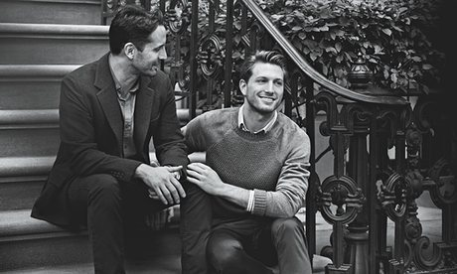

The Lynx effect: ad land begins to reflect the lives of gay men

Read more

8. Pantene: Labels against women (2013)
While, if we’re honest, we’re not totally in love with the creative execution of this one, the insight is undeniably great. In their press release, to emphasise the truth behind their advert, Pantene used the statistic that 70% of men believe women should “downplay their personality to be accepted” in the workplace. We can’t help think that it is opinions like this which has resulted in a shocking lack of women in big business. In fact, there are more large companies run by men called John than by women, which isn’t at all gut-wrenchingly depressing. As such, this advert, and pretty much anything which challenges the stereotype of women in business, can only be good. Plus, her hair really does look very healthy.
Pantene’s ad attacks gender bias.
We have to applaud the Cannes Lion glass award for recognising the need to spur the advertising industry on with regards to gender. It feels like we are facing a tipping point, where even targeting by classic gender roles (mums has to be the laziest ever descriptor to hit an advertising brief) feels increasingly outmoded. Worse than that, there are penalties for getting it wrong; groups who will shame your brand on social media, deface your posters on the street, even boycott you at the tills. Advertising needs to catch up with society to the point where this award is redundant. After all, it is made out of glass, while every other Cannes award is cast iron. We, personally, are reading this as an open invitation to ritually smash it to pieces.
Mel Exon is the managing director and Melanie Arrow is a strategy director at BBH London
To get weekly news analysis, job alerts and event notifications direct to your inbox,sign up free for Media Network membership.
All Guardian Media Network content is editorially independent except for pieces labelled “Brought to you by” – find out more here.

