Act 5 Reading Questions
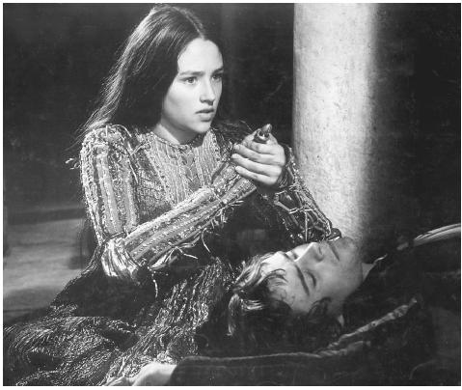
Act 5, Scene 1
- We have seen several instances of foreshadowing in this play. How does Romeo’s opening speech foreshadow events in the play?
- How does Romeo hear of Juliet’s “death”? What does he decide to do?
- How does he convince the apothecary to give him poison even though its sale is punishable by death in Mantua? What does he say is worse than the poison he is sold?
Act 5, Scene 2
- Why was the Friar’s message to Romeo delayed and why does it matter?
- What does the Friar resolve to do?
Act 5, Scene 3
- Who appears at Juliet’s tomb and why?
- Who appears next and why?
- Who’s hiding and watching?
- Why does a fight break out? Who dies? Who runs to get the watchmen?
- Do you feel sorry for Paris’s part in this play?
- I mentioned earlier that pacing is important in this play. How is it important in this pivotal scene?
- Dramatic irony happens when there is a discrepancy between what a character says or thinks and what the reader knows to be true, when the author lets the reader know something that the character doesn’t know. How is dramatic irony important in this scene?
- How does Romeo die? What do you make of his death?
- Who shows up at the tomb next and why?
- How does the Friar make sense of what has happened and what does he urge Juliet to do as she awakes and asks for Romeo? Why does the Friar run away?
- What does Juliet do once the Friar leaves and she sees Romeo is dead?
- What do we learn about Romeo’s mother?
- The end of the play contains a summary of the main events and then the Prince provides his moral outlook on the events, saying to the Capulets and Montagues, “See what a scourge is laid upon your hate,/That heaven finds means to kill your joys with love” (5.3.291-2). The two families agree with the Prince’s interpretation of the events, seeing their dead children as “poor sacrifices of our enmity” (5.3.303). What do they agree to do at the end of the play?
- What lessons should we learn from this tragedy, “For never was a story of more woe/Than this of Juliet and her Romeo” (5.3.308-9)?
- Why is this story considered one of the greatest love stories of all time? Do you think it deserves this label? Did it teach you anything about love?

